IoT Progress Report
IoT Connected SmartHub Dashboard
____________________________________________________________________________
Thiago Costa, Johannes Hirt, and Anar Amartuvshin
Introduction
For our project, we are developing an IoT based SmartHub Dashboard using two ESP32 devices and multiple communication technologies. The system is designed for student use and is able to display essential information such as time, music playback, and room temperature data. Bluetooth Low Energy (BLE) is implemented for short-distance communication between nearby devices, while LoRa is implemented for long-distance data transmission. WiFi is used for features such as web server access and remote interaction. The main ESP32 device acts as the central SmartHub, connecting to multiple components including the display, which contains its own ESP32 microcontroller, a secondary ESP32 LoRa node, a speaker, and other components. Additional components such as a camera and a servo motor are for auto-rotating the screen using hand gestures. We are training our own model by taking many samples through the camera.
Overall, the goal of this project is to create a user-friendly dashboard that has access to multiple functionalities into a single SmartHub device, providing students with convenient access to useful information. Everything from one desk SmartHub.
Current Status
Overall:
After ordering the necessary components for our system, we were finally able to test out individual components and set up each wireless communication method. We have also updated our architecture as shown below in Figure 1, which illustrates the main controller’s connections to all subsystems, such as display, LoRa transmitter, camera, BLE connection, web server, and servo. PlatformIO is used as the development environment for our codebase.
- LoRa: (Johannes)
We have successfully implemented the LoRa communication between two Heltec WiFi LoRa 32 V3 development boards, where one node collects sensor data and transmits it back to the main SmartHub. Since the Heltec board contains an onboard SX1262 LoRa radio, we are able to establish communication between the transmitter and receiver using the provided spring antenna. The system operates at the RF frequency of 915 MHz, which falls within the US ISM band as discussed during class. The code is based on the Arduino LoRa communication example and has been modified for our system. We are also reading the Received Signal Strength Indicator or RSSI for measuring how strong the received signal is in dBm and SNR or Signal-to-Noise Ratio to assess signal reliability.
- Motor: (Johannes)
The system uses a high-torque servo motor (HPS-2027), from the Chinese manufacturer Hiwonder, to rotate the display based on user input. The servo is rated for approximately 20 kg·cm of stall torque. It is controlled by the ESP32 and enables automatic screen orientation through hand gesture commands, such as swipe up, down, left, and right. Tests completed so far include rotating the servo to specific angles based on user input.
Currently, the servo requires a 6–8 V power supply, and we have not yet identified a suitable battery. For testing purposes, we have been using a classroom bench power supply. The goal is to attach the servo to the display and achieve rotation of ±90°.
- Screen: (Thiago)
The 7-inch CrowPanel display we purchased has been tested, and we have implemented a basic UI that includes features such as a timer and animated music playback bars, as shown in Figure 1. The screen is configured as an 800×480 RGB display. We are using the open-source LVGL graphics library for our GUI, which renders the screen in chunks for memory efficiency .
The screen supports rotation in both portrait and landscape orientations. In addition, we have successfully implemented Spotify music playback control using a Spotify Premium account. We are now able to control play, pause, and skip functions directly from our SmartHub. Using a weather API, we are also able to display live weather information on the screen. The display has multiple pages that the user can switch between using a side button. We are also able to control the screen brightness.

- BLE and Wifi Connection: (Anar)
We aimed to implement a battery level indicator on the UI using Bluetooth Low Energy (BLE) communication. The initial idea was to retrieve battery status from nearby devices such as phones, earbuds, and tablets. However, Apple devices have strict security restrictions, and the ESP32 was unable to establish a connection, even though the devices were visible in the nRF Connect application. Apple devices do not advertise accessible BLE services for battery data to external devices like the ESP32.
The Apple Shortcut workflow operates as follows: we build data-retrieval blocks within the Shortcuts app on the iPhone, which then transmits the data via an HTTP request over WiFi to the ESP32's web server. The ESP32 parses the received values and displays them on the OLED.
In addition, BLE communication has been successfully implemented for short-range use. We were able to establish connections with BLE helper applications such as nRF Connect, confirming that data can be transmitted and received correctly. As a next step, we plan to detect nearby Android devices using their MAC addresses for identification purposes. Since Apple devices are not easily accessible via BLE, we are focusing on Android devices.

Work Completed
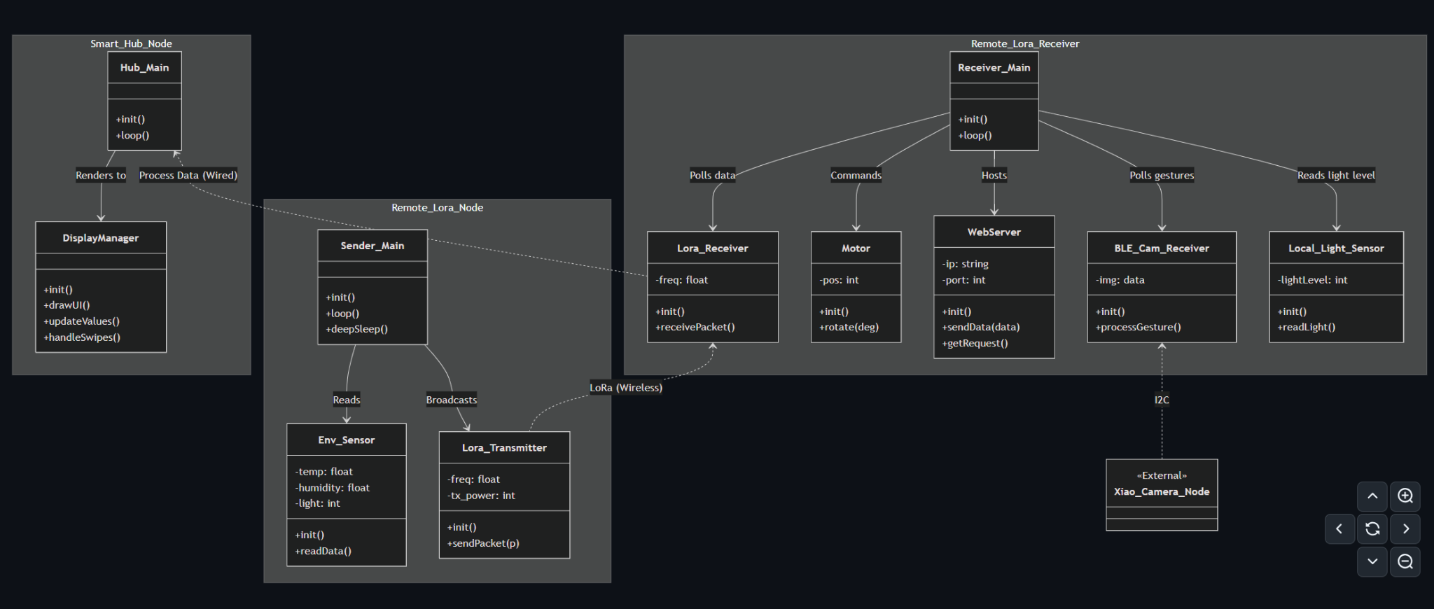
Figure 1: Current Architecture Diagram (Johannes)
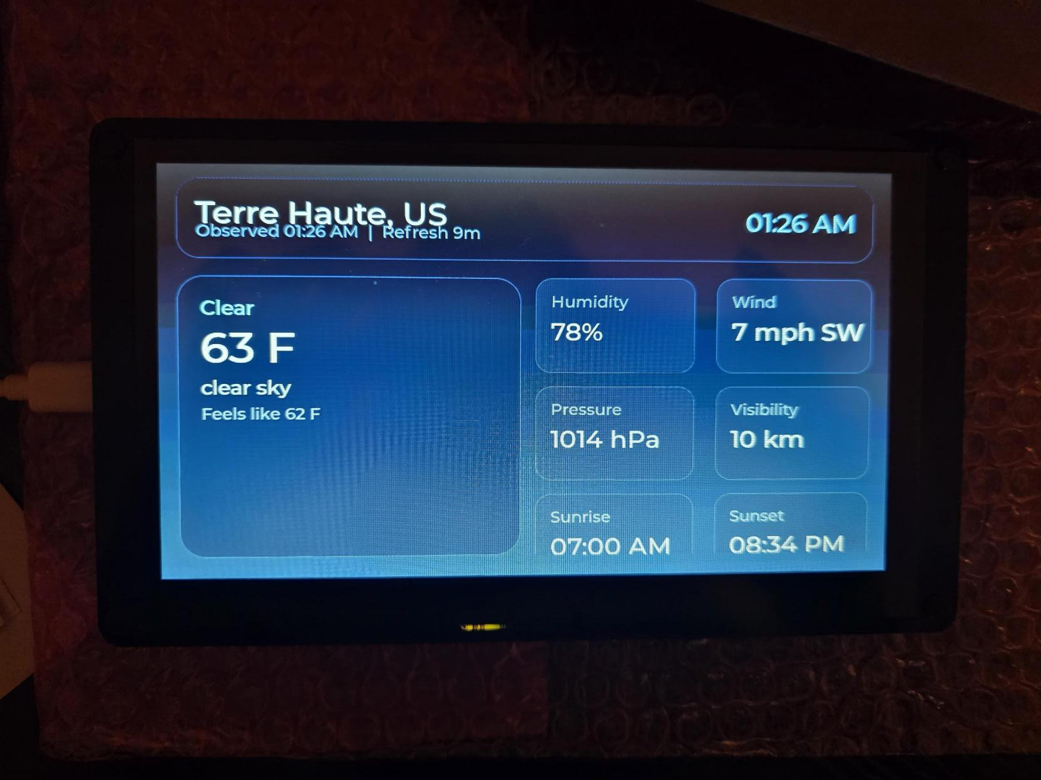
Figure 2: Example UI rendered on the CrowPanel display. (Thiago)
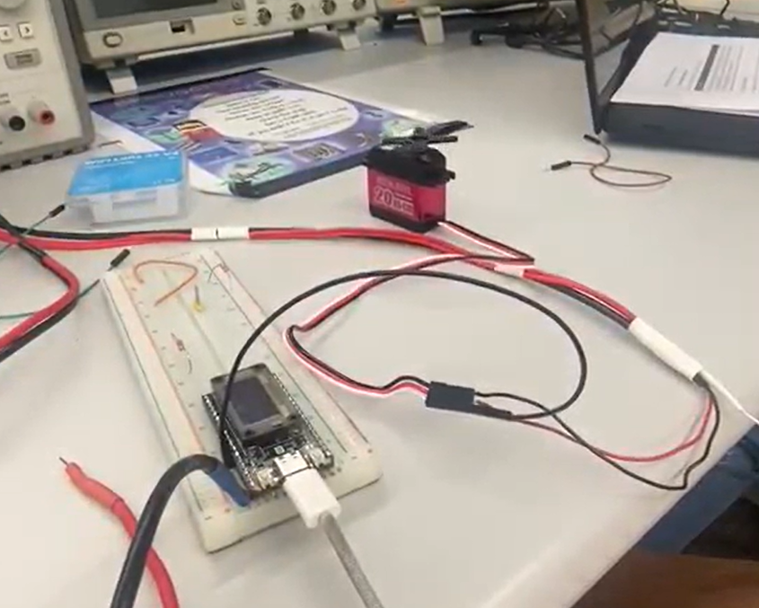
Figure 3: Servo motor test setup. To watch a demo video: Click here to watch a demo video (Johannes)

Current Work
Camera Set up: We are currently working on implementing hand gesture recognition. The camera is being trained to detect gestures such as swipe right, swipe left, swipe up, swipe down, and an idle state. So far, we have collected approximately 2,000 samples for training. The next step is to label the dataset by annotating bounding boxes around the hand in each image. More information is shown in Figure 4 below. Since the ESP32 has very limited memory and processing power, it cannot handle large, high-resolution color images. Therefore, images are resized to 96×96 pixels and converted to grayscale, which reduces both memory usage and computation.
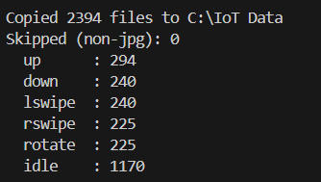
Figure 4: Camera gesture training progress.

Currently, the accuracy of the camera-based gesture recognition is relatively low due to model optimization techniques used to reduce latency and memory usage, making it suitable for deployment on the ESP32, as shown in Figure 5.
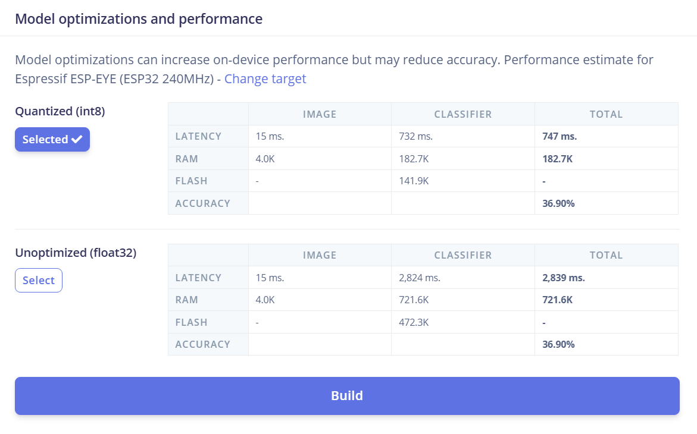
Figure 5: Training accuracy of the camera hand gesture recognition system.

Objectives
- System Integration - All
Integrate all subsystems — LoRa, WiFi, BLE, display, and servo — into a single SmartHub. Ensure communication remains reliable across all interfaces.
- User Interface Development -Thiago
Finalize the user interface with real-time data updates and ensure smooth, responsive data display.
- Gesture recognition- All+Thiago mostly
Implement camera-based hand gesture control (left swipe, right swipe, up, and down) and map gestures to display actions such as portrait/landscape rotation and page switching.
- Completing BLE device detection- Anar
Improve BLE functionality to detect and interact with nearby devices, focusing on Android phones.
- Web interface and Remote Control- Johannes
Develop a web-based interface to allow users to monitor the system remotely.
- 3-D printing the screen stand- All
Design and 3D-print a stable enclosure and mount the servo to the screen.
- Camera assembly-Anar
Solder a wired connection between the camera module and the ESP32 development board.
- Power System- All
Identify the proper power solution for all components and finalize the decision for the system. Define total power requirements.
- End-to-end testing of all combined systems — All

Test Plan
- Camera Gesture Recognition- Thiago
  - Label all collected data samples.
  - Verify the accuracy of the gesture.
- LoRa Communication- Johannes, Anar
  - Verify complete data transmission between the transmitter and receiver at multiple distances.
- BLE Communication-Anar
  - Scan for and select nearby BLE devices, targeting Android devices.
  - Verify successful BLE connection establishment.
  - Complete data transmission testing over BLE.
- Display and UI testing- Thiago and Johannes
  - Verify the correct rendering of UI elements overall.
  - Ensure proper functionality in both landscape and portrait orientations as a final check after adding all elements.
- Servo Motor
  - Ensure stable operation with external power supply. Currently verified with a classroom bench power supply.

